

**Placement Empowerment Program**

***Cloud Computing and DevOps Centre***

**Set Up a Virtual Machine in the Cloud**Create A free-tier AWS, Azure, or GCP account. Launch a virtual machine and SSH into it.

Name: Harivasan S

Department: ADS



**Introduction :**

In the modern digital era, cloud computing has transformed IT resource management and deployment. Virtual machines (VMs) enable users to run multiple operating systems on a single physical server, offering scalability, flexibility, and efficiency. This guide outlines the steps to create a virtual machine in the cloud using a free-tier account on AWS, Azure, or Google Cloud Platform (GCP).

**Objective:**

The objective of this tutorial is to enable you to:

1. Create a free-tier account on a cloud provider (AWS, Azure, or GCP).
2. Launch a virtual machine.
3. Connect to the VM using SSH (Secure Shell) for secure **Steps to Set Up a Virtual Machine in the Cloud**

**Step 1:**

Open AWS management console and search for EC2 instance

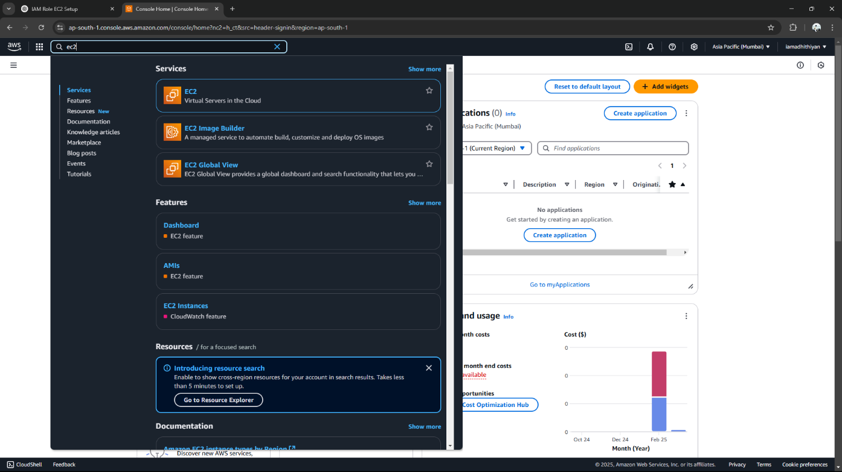

**Step 2:**

**Launch an instance in amazon linux**

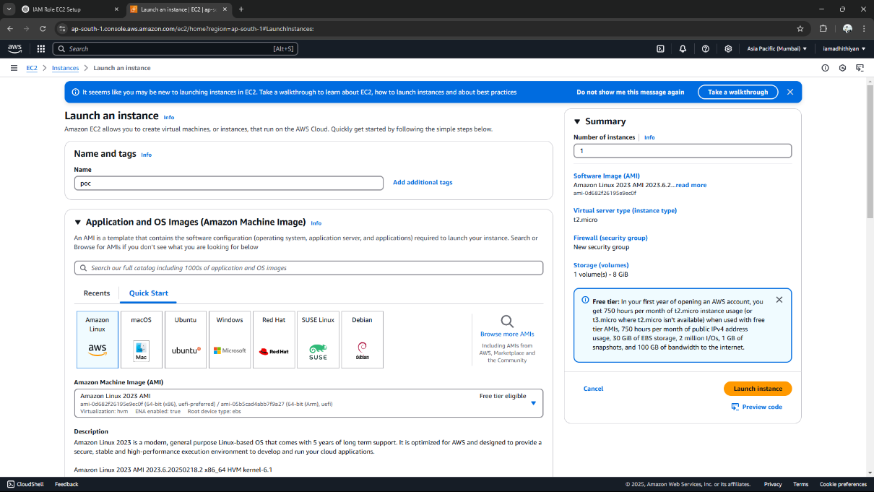

**Step 3:**

**SSH into the Virtual Machine by copying the command**

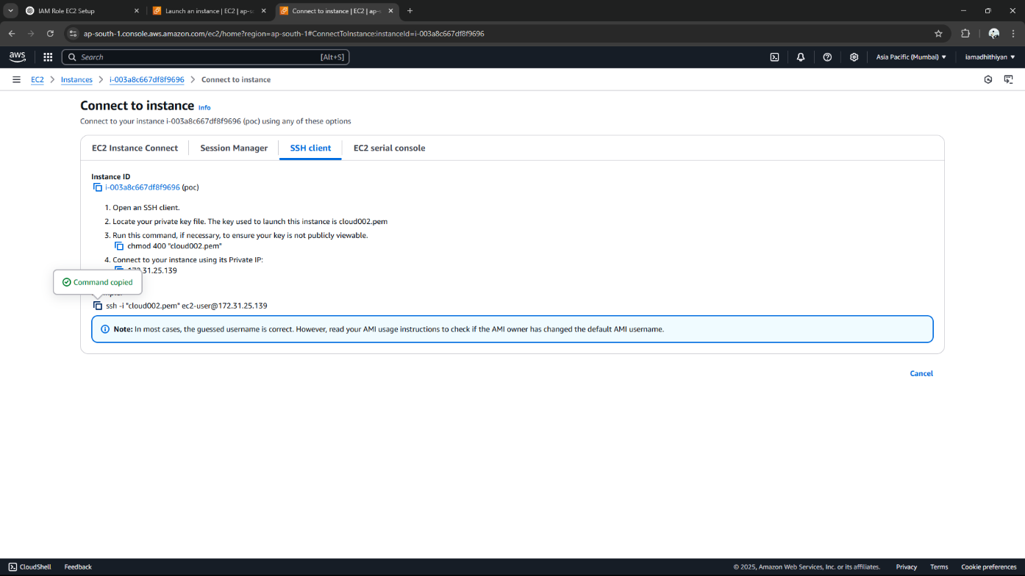

**Step 4:**

**Finally it will display the virtual machine**

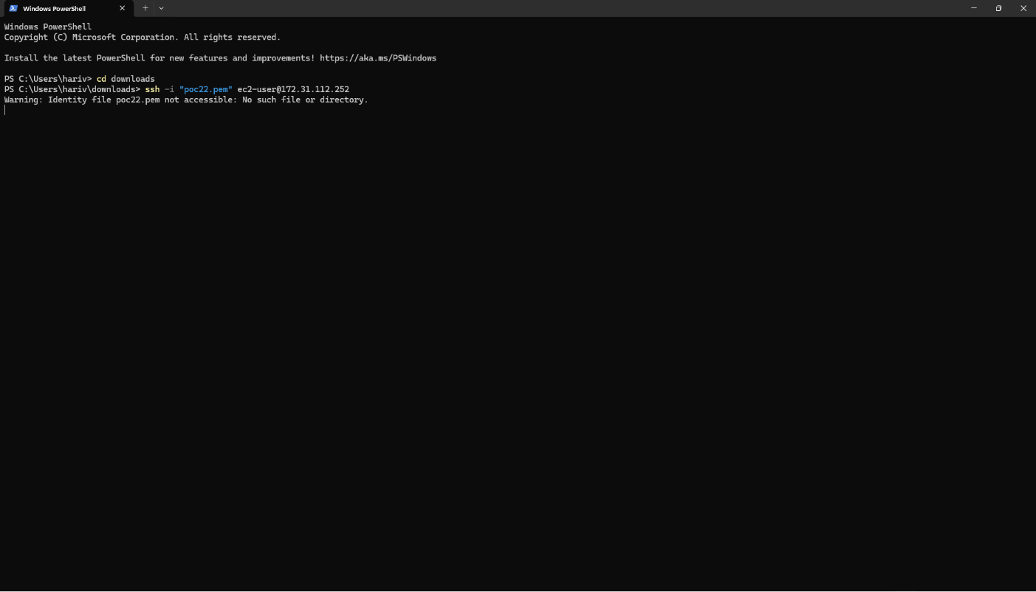

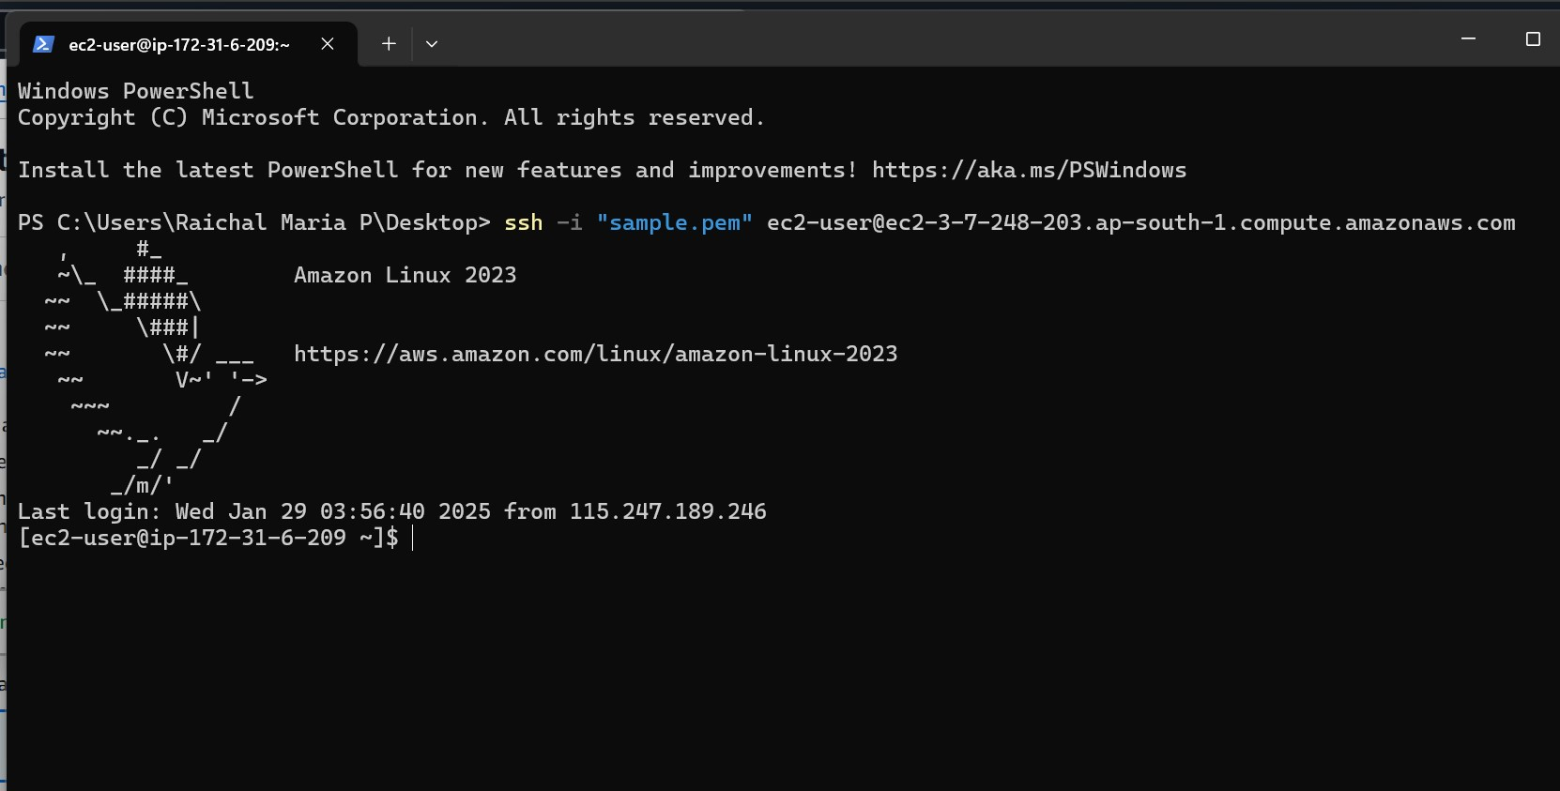

**Expected Outcome:**

* Successfully deployed a virtual machine in the cloud and established an SSH connection.
* Ready to explore additional configurations and customize the environment.
* Install software and optimize the instance for various applications.
* Utilize cloud resources efficiently for different use cases.
* Enjoy seamless cloud computing!